BUSINESS CASE  
Investment Appraisal

JOURNEY PLANNER

horizontal line

# 

# 

# 

Introduction **1**

Background **2**

Management Summary **3**

Description of the problem and opportunity **4**

Options available and considered **5**

Cost/Benefit analysis **6**

Impact and Risks **8**

Conclusions and Recommendations **10**

References **11**

## Introduction

A Business Case document is designed to break down the approach and decisions throughout this project. This is so that during development, we are open about our approach and the company's financial benefit during this product life cycle. This is so that both client and developer have a mutual understanding of how to reach the required results and that the stakeholders will be informed on their return from the project and how that will be achieved.

(Association for Project Management, n.d.)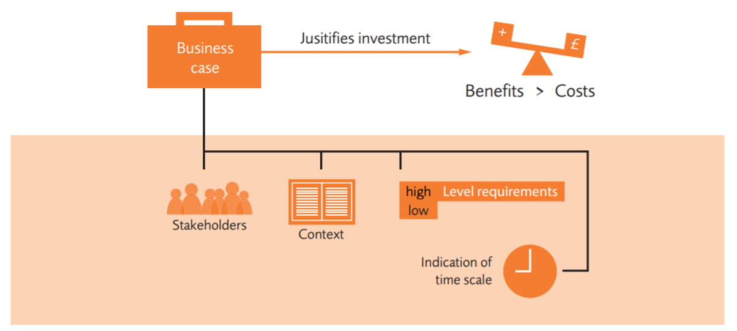

We are creating this business case specifically to represent our company’s possible solution to the financial and technical issues occurring with the current system at South Yorkshire Buses.

We will be assessing the following:

* The business problem and possible solutions
* Benefit and Risks
* Cost both outgoing and incoming
* Timescale for development
* Impact
* Our capability to develop our solution.

In providing these answers to the stakeholders, we will be providing all solutions to possible questions that will be asked, which will lead to the approval or disapproval of this project.

## Background

South Yorkshire Buses (SYB) are a travel company looking for ways to modernise its customers' travel experience.

The company has lost around £60.000 every year on license fees and hosting the current journey planner they own. The system is outdated, not up to the standard of other competitive applications, and deals with multiple faults regarding the accuracy of travel times or live traffic updates.

SYB has spent up to £500 per every change they have found necessary to try and improve their system but has concluded that it is finally worth investing in a team of IT professionals that can provide a modern and accurate journey planner.

## Management Summary

As a technology solution company, BBB provides consultancy services to companies like South Yorkshire Buses. The main objective of South Yorkshire Buses is to provide its customers with a modern and accurate journey planner. The proposed solution will apply features such as live travel updates and getting from A to B.

The time and cost of the application are the main problems this solution will address. The deadline for the journey planner is the 31st of March, 2023. It will be necessary to allocate staff accordingly to ensure the development process of this project reaches the intended date. This will reduce the cost spent on unwanted features. Following these procedures, the time and cost will not impact the application's overall quality.

For this project, we target young adults, middle-aged people, and the elderly. By using the planner, these audiences can purchase various tickets and plan ahead for future bus trips. As a result, customers can book and plan bus trips much more quickly.

Since the company already spends £60,000 on license fees and $25,000 on annual changes on its current solution, the newly proposed solution is much more cost-effective. The company will save 45% on a more suitable product by using the newly proposed solution. These new figures are expected to generate upwards of £60,000 in profits annually.

According to early customer feedback, the cheaper solution will not impact the quality or value of the product or brand, but this is a risk that is considered during the design process. As a result, the team will focus on the project strategy six months before launch to mitigate that risk.

Overall, the cheaper and more practical methods will allow us to break into a new market and increase the company's expenditures. We expect the company to lead to a high-profitable change, with profits expected to be 45% higher than the current solutions.

## Description of the problem and opportunity

South Yorkshire Buses would like to offer their customers an efficient way of planning and travelling from one point to another. This will be achieved through free access to an application that enables users to view information about bus travel times, routes, stops and stations, and ticket prices.

The current software that SYB is providing is inefficient, is not accessible on all platforms, and it is inaccurate, thus resulting in decreasing customer satisfaction. Since the launch of the most popular journey planner and SYB’s biggest competitor, Travel South Yorkshire, the company has seen a significant decrease in users. It continues to lose around 10% of customers every month. The cost of hosting the system and the inability to satisfy its users have led the company to invest in a modern and fast application.

The main issue this project will address is finding a way to attract customers and provide them with an accurate journey planner. Our team of IT professionals has gathered a list of fundamental features that integrate all the major functionalities of a modern application. The users will have access to information about different buses(travel times, route, stops and stations, ticket prices), will be able to plan a journey step by step(including the suggestion of other ways of transportation where necessary - trains, trams, etc.), will get live traffic updates and rerouting in case of any road closures. Furthermore, the application will provide a ticketing system that lets users view, compare, and buy different-priced tickets and opt for the best ones.

This project proposes to reduce the cost of hosting and licensing fees of the application. The annual cost of the current system is £60.000, with another £500 spent on every change or update requested. However, the budget for building the new Journey planner is £60.000. The investment, the costs of any associated third-party software, and customers' popularity will lead to a good and profitable change.

## Options available and considered

This project is going to require the creation of an application. Generally, most applications come in the form of a web app, mobile app, or a native windows/mac program. As the users of the application will likely be on the go with no access to a windows/mac machine, it would not make much sense to produce an application for these platforms. A web application could be a good choice, as it would be accessible on every device capable of running a web browser. If the journey planner is to be a mobile application, it would be accessible to most people. It could also make use of native features - such as being able to use the application without an internet connection.

We have concluded that a mobile application would be best suited for the South Yorkshire Buses Journey Planner. We think this because most people carry a smartphone with them everywhere they go, meaning they can access the journey planner on the go. Another reason is that native mobile applications provide offline storage. This would allow application features, such as a bus timetable, to be used even if the user is in a remote area with no internet connection.

The application requires some sort of mapping solution so that users can visualise their journeys. Bing, Waze, and Google all have excellent mapping capabilities. However, the users of any journey planning application expect the highest level of accuracy when it comes to time estimations. Google Maps has always been the most popular option amongst travellers. Because of this, Google can collect a vast amount of live data that it can use to accurately predict the amount of time it takes to travel from point A to B. And for this reason alone, we are opting for Google’s mapping solution so that the people of South Yorkshire can trust that their public transport will get them to their destinations on time.

As for hosting the application, we can either pay for our servers or opt for a cloud service provider. Because our company does not have any staff specialising in running servers, opting for a cloud service provider would be the best option. There are many options for web service providers - the leading players are Amazon Web Services, Google Cloud Platform, and Microsoft Azure due to their high levels of trust and reliability. These are all excellent providers. However, we are opting for the Google Cloud Platform as we will use Google for our mapping solution and directions API. This will allow us to manage the vast majority of services required by the journey planners all through one cloud platform.

## Cost/Benefit analysis

The average number of users of the current Journey Planner application is just 100.000/month, and 1 million unique users/year.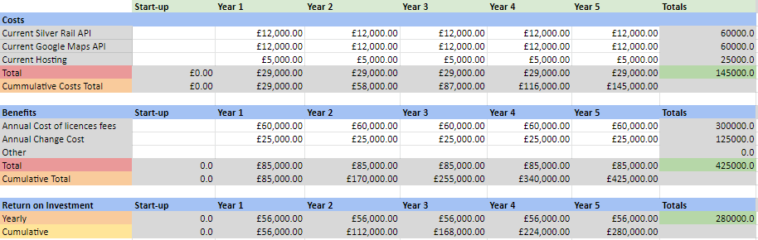

Costs

The price of both Google Maps API and Silver Rail API has been calculated at 200.000 calls/month, each giving us a price of £12,000.00/year (each of the APIs individually).

While Silver Rail API gives us more accurate and consistent data regarding bus information or live traffic updates, the Google Maps Route API gives us a more detailed view of the route. Thus, combining the two APIs will provide the user with an accurate and reliable experience.

The average price for hosting a business-level web application such as the Journey Planner is £5,000.00/year.

Benefits

The current price paid by South Yorkshire Buses for hosting and licensing fees is £60,000.00/year.

The average number of yearly changes and updates the company has to undertake is around 50. Considering that the cost of one individual change is £500, the SYB company pays £25,000.00/year at the time.

Return on investment

Based on the facts presented above, it has been calculated that the company’s yearly profit will be £56,000.00/year.

## Impact and Risks

1. Natural Disasters

**Impact:** Large damage to physical property and large amounts of downtime.

**Control:** Back up data and essential files to the cloud.

1. Unclear Scope

**Impact:** Plans and Project details will constantly be changing.

**Control:** Ask the client as many questions as possible to get as many ideas as possible. Further changes can be dealt with in weekly meetings.

1. Going Over the Budget

**Impact:** Project will spend over our guaranteed budget leading to stakeholders being displeased and possibly abandoning the project.

**Control:** Keep the Cost Benefit Diagram constantly updated so we can keep track of our finances. If the budget is over, then renegotiations with the client.

1. Project Not Being Delivered on Time

**Impact:** Project will go over our timeframe leading to stakeholders being displeased and possibly abandoning the project.

**Control:** To prevent this, we need to stay on top of our scope to avoid last-minute changes to the project and stay on top of the Gantt chart so that we are on track.

1. Customers' Lack of Technical Skills

**Impact:** The customers cannot use the software they have created, leading to changes to the system.

**Control:** Prevention can happen by testing thoroughly to fit for purpose.

1. Server Going Down/Being Overloaded

**Impact:** The system may go down due to a technical fault or too many people using the system at once.

**Control:** Fix the system when it goes down. Test Thoroughly.

1. DDoS attack

**Impact:** System will go down, and data will be lost.

**Control:** Keep systems secure by ensuring high levels of network security.

1. Inaccurate bus timetables

**Impact:** The data that we provide to the customer will be wrong.

**Control:** Keep API calls frequent.

## 

## Conclusions and Recommendations

In conclusion, the Business Case document outlines and explains the overall cost/benefit analysis. Based on the results of our research, we can affirm that by redesigning and maintaining the current Journey Planner, the SYB company will be able to provide its customers with a modernised application that can compete with more popular businesses.

The main result of the Business Case visualises the companies’ annual Return on Investment, which has been defined as being ‘profitable’ starting with Year 1.

As part of the one-month review and testing period, our team will execute any perfective maintenance required by the client. Our company will cover all the costs of the changes.

## 

## References

Association for Project Management. (n.d.). *What is business case?* APM. Retrieved November 13, 2022, from https://www.apm.org.uk/resources/what-is-project-management/what-is-a-business-case/